# Lab Task 2:

**Student Management System**

**Facts (55nos)**

branch(cs,amal).

branch(cs,rohit).

branch(cs,neha).

branch(cs,nehal).

branch(ece,vena).

branch(cs,kiran).

branch(ece,gowri).

studies(cse501,cse502,amal).

studies(cse502,cse501,rohit).

studies(cse501,cse502,neha).

studies(cse501,cse502,nehal).

studies(ece501,ece502,vena).

studies(cse501,cse502,kiran).

studies(ece502,ece501,gowri).

teaches(cse502,manoj).

teaches(cse501,ram).

teaches(ece501,swetha).

teaches(ece502,anitha).

electiveoption(os,dsa).

electiveoption(dsa,lp).

electiveoption(pe,qm).

coursecredit(4,cse501).

coursecredit(3,cse502).

coursecredit(4,ece501).

coursecredit(2,ece502).

femalestudent(nehal).

femalestudent(vena).

femalestudent(swetha).

femalestudent(neha).

femalestudent(gowri).

malestudent(amal).

malestudent(rohit).

malestudent(kiran).

classrep(gowri).

subject_guide(cse501,rupa).

subject_guide(cse502,sita).

subject_guide(ece501,swarup).

subject_guide(ece502,pravin).

attendance(30,rohit).

attendance(80,amal).

attendance(50,neha).

attendance(10,neha).

attendance(76,karthik).

attendance(90,gowri).

attendance(80,vena).

averagescore(amal,84).

averagescore(karthik,20).

averagescore(gowri,65).

averagescore(vena,15).

team(amal,rohit).

team(rohit,neha).

**Rules (15nos)**

classmates(Y,X):- branch(A,X),branch(A,Y).

professor(Y,X):-teaches(C,X),(studies(C,_,Y);studies(_,C,Y)).

subjectcredit(Y,Z,X):- studies(D,E,X),coursecredit(Y,D),coursecredit(Z,E).

studentsladieshostel(X):-femalestudent(X),branch(_,X).

faculty(X):-teaches(_,X);subject_guide(_,X).

ashramsidehostel(X):-malestudent(X),branch(_,X).

shecodemember(X):-femalestudent(X),subjectcredit(4,3,X).

biosmember(X):- branch(ece,X);branch(cs,X).

codingclubmember(X):- studies(cse501,_,X);studies(_,cse501,X).

canwriteexam(X) :- attendance(Y,X), Y >= 75.

failedexam(X) :- averagescore(X,Y), Y =< 20.

firstclass(X) :- averagescore(X,Y), Y > 20, Y=<80.

distinction(X) :- averagescore(X,Y), Y >= 80.

classcommittemembers(X):- faculty(X);classrep(X).

projectguide(Y,X):-subject_guide(H,X),studies(H,_,Y),branch(cs,Y).

projectguide(Y,X):-subject_guide(H,X),studies(H,_,Y),branch(ece,Y).

projectgroupmember(X,Z):- team(X,Z).

projectgroupmember(X,Z):- team(X,Y),projectgroupmember(Y,Z).

elective(X,Z):- electiveoption(X,Z).

elective(X,Z):- electiveoption(X,Y),elective(Y,Z).

classmates(X,Y):- branch(X,A),branch(Y,A).

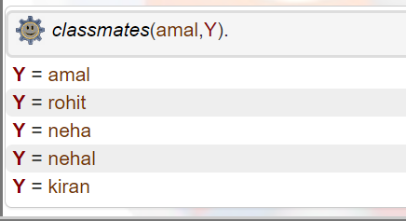

professor(Y,X):-teaches(C,X),(studies(C,_,Y);studies(_,C,Y)).

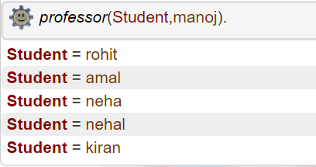

subjectcredit(Y,Z,X):- studies(D,E,X),coursecredit(Y,D),coursecredit(Z,E).

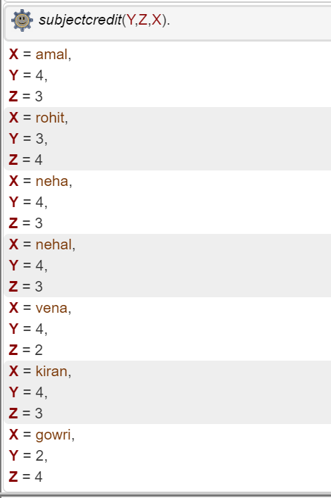

*ladieshostel*(nehal).

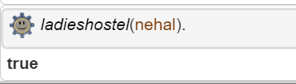

faculty(X):-teaches(_,X);subject_guide(_,X).

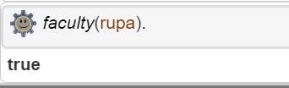

ashramsidehostel(X):-malestudent(X),branch(_,X).

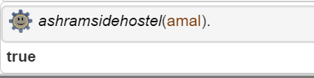

shecodemember(X):-femalestudent(X),subjectcredit(4,3,X).

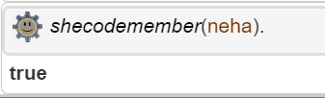

biosmember(X):- branch(ece,X);branch(cs,X).

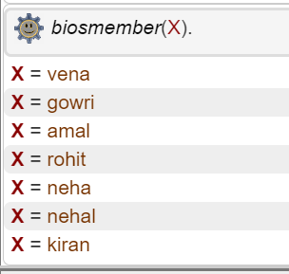

codingclubmember(X):- studies(cse501,_,X);studies(_,cse501,X).

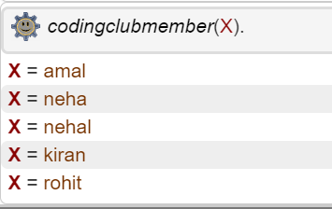

canwriteexam(X) :- attendance(Y,X), Y >= 75.

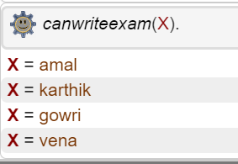

failedexam(X) :- averagescore(X,Y), Y =< 20.

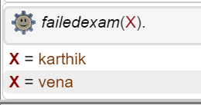

firstclass(X) :- averagescore(X,Y), Y > 20, Y=<80.

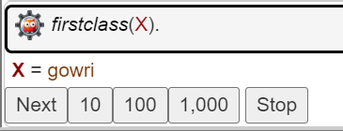

distinction(X) :- averagescore(X,Y), Y >= 80.

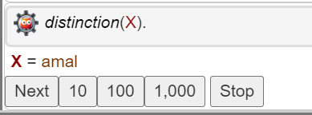

classcommittemembers(X):- faculty(X);classrep(X).

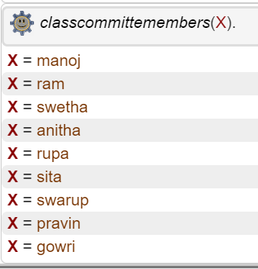

projectguide(Y,X):-subject_guide(H,X),studies(H,_,Y),branch(cs,Y).

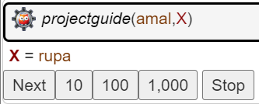

projectguide(Y,X):-subject_guide(H,X),studies(H,_,Y),branch(ece,Y).

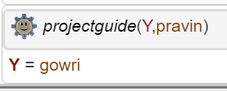

projectgroupmember(X,Z):- team(X,Z).

projectgroupmember(X,Z):- team(X,Y),projectgroupmember(Y,Z).

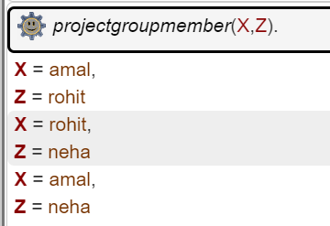

elective(X,Z):- electiveoption(X,Z).

elective(X,Z):- electiveoption(X,Y),elective(Y,Z).

